Financial News Entity Extraction

Project Description:

The Financial News Entity Extraction project aims to automatically extract key financial entities—such as COMPANY, TICKER, CURRENCY, INDICATOR, and EVENT—from unstructured business news articles. Using transformer-based NLP models (BERT/FinBERT), the system converts raw financial text into structured insights that analysts, investors, and organizations can use for faster decision-making.

The project includes dataset creation, model training, evaluation, visualization, GUI testing, and deployment via FastAPI.

Project Scenarios

The purpose of this project is to build an intelligent system that can automatically identify important financial terms from news articles.

Financial news often contains information about companies, currencies, stock tickers, economic indicators, and financial events.

Manually reading all this information is time-consuming, so an automated model helps extract key insights quickly.

To solve this problem, the project uses Natural Language Processing (NLP).

Different machine-learning models are trained to recognize entities inside text, including:
- Logistic Regression
- Ridge Classifier
- Decision Tree
- Random Forest
- Support Vector Machine (SVM)
- A fine-tuned BERT-based Transformer model

Each model learns patterns from a dataset containing financial news sentences and their labeled entities.

After training, the models are tested to compare accuracy and overall performance.

Among all models, BERT performs the best because it understands context deeply and handles complex sentence structures.

Classical ML models act as baselines for comparison.

Finally, a Flask-based backend is created to serve the trained model, and a simple frontend interface is developed where the user can type any financial sentence and see extracted entities highlighted.

This turns the trained machine-learning model into a usable mini-application.

Prerequisites:

Google Colab

The entire model development, training, testing, and visualization can be done in Google Colab with free GPU support.
Link: https://colab.google.com/

Visual Studio Code (VS Code)

Used for:

Editing main.py (FastAPI backend)

Editing index.html (Frontend GUI)

Organizing folders & deployment files

Prior Knowledge Requirements

Before starting the project, you should understand the following:

Natural Language Processing

Tokenization

Lemmatization

Stopword removal

Named Entity Recognition (NER)

Machine Learning Basics

Training/testing workflow

Evaluation metrics: Accuracy, Precision, Recall, F1-score

Confusion matrix & Heatmap analysis

Deep Learning Concepts (Optional but helpful)

Transformer models

Attention mechanisms

API Development Concepts

JSON structure

Endpoints

POST/GET request handling

FastAPI Framework

Creating API routes

Serving ML predictions

Running a local server using Uvicorn

Python Packages Required

Open Anaconda Prompt as Administrator and install all the required packages.

Core Packages

pip install numpy

pip install pandas

pip install scikit-learn

pip install scipy

Visualization Packages

pip install matplotlib

pip install seaborn

NLP Packages

pip install spacy

pip install transformers

pip install sentencepiece

Download the English language model:

python -m spacy download en_core_web_sm

Model Serialization / Utilities

pip install pickle-mixin

Deployment Packages (FastAPI)

pip install fastapi

pip install uvicorn

pip install python-multipart

pip install jinja2

Optional – GPU Acceleration (If running locally)

Install CUDA-enabled PyTorch:

pip install torch torchvision torchaudio --index-url https://download.pytorch.org/whl/cu118

Project Flow:

User enters financial news text.

System preprocesses the input.

Trained NER model extracts entities (Company, Ticker, Currency, Event, Indicator).

Results and confidence scores are displayed.

System returns structured JSON + highlighted output.

Project Activities

1. Data Collection & Preparation

Collect training & testing datasets.

Clean, label, and preprocess data.

2. Exploratory Data Analysis

Summary statistics.

Visual analysis (charts, heatmaps).

Entity distribution study.

3. Model Building

Train NER model (spaCy/Transformer).

Test multiple algorithms.

4. Model Evaluation

Evaluate accuracy, precision, recall, F1.

Compare models and select the best.

5. Deployment

Save best model.

Deploy using FastAPI with HTML UI.

Project Structure:
Create the Project folder which contains files as shown below

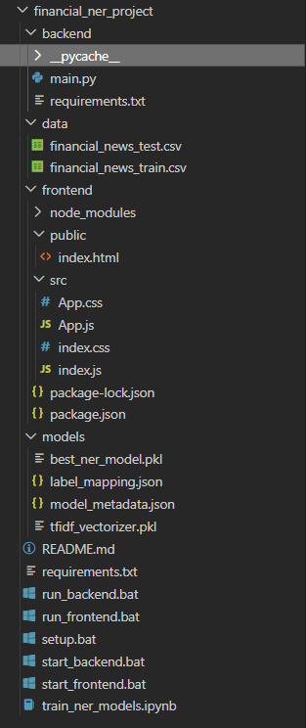

Project Structure Explanation
- static/
Contains static assets (CSS, JavaScript, uploaded images)
  - style.css – Application styling
- templates/
HTML templates for Flask application
  - index.html – Landing page
- main.py
Flask application backend
- RidgeClassifier_model.pkl
Trained model file
- GEN_AI_project.ipynb
Jupyter notebook with model training code
- Dataset
financial_news_test.csv
Financial_news_train.csv

Activity 1.1: Collect the Dataset

There are many open-source platforms for collecting textual datasets such as Kaggle, UCI Repository, HuggingFace Datasets, and financial news sites.
For this project, we prepared two CSV datasets:

Training Dataset: Financial news samples with entity labels

Testing Dataset: Additional news samples for evaluating the model

Both datasets are in .csv format for easy preprocessing and annotation.

Dataset Source

Since financial NER datasets are not widely available for free, a custom dataset was generated and curated specifically for this project.

The dataset contains short financial news headlines and descriptions, each annotated with one or more of the following entity labels:

COMPANY – Company names mentioned in the news

TICKER – Stock market ticker symbols

EVENT – Financial events (mergers, acquisitions, funding, layoffs, earnings announcements)

CURRENCY – Currency names or symbols

INDICATOR – Economic or financial indicators (GDP, inflation, interest rate)

Dataset Structure

Each row in the dataset contains:

Text — A financial news headline or summary

Entities — A dictionary or list of labeled entities extracted manually or semi-automatically

Example:
Text | Entities
"Apple acquires AI startup WaveTech for $200M" | {"COMPANY": ["Apple"], "EVENT": ["acquires"], "COMPANY2": ["WaveTech"], "CURRENCY": ["$"], "INDICATOR": []}

The dataset file names are:

train_dataset.csv — Used for training the NER model

test_dataset.csv — Used for evaluating model performance

Purpose of This Milestone

After downloading or preparing the dataset, we proceed with:

Reading and exploring the data

Cleaning the text

Visualizing entity distribution

Understanding the frequency and patterns in financial news content

This lays the foundation for the next milestone: Exploratory Data Analysis (EDA).

Activity 1.2: Importing the Libraries
Import the necessary libraries as shown below:
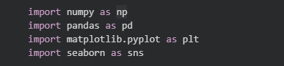
These libraries serve the following purposes:
- NumPy: For numerical computations
- Pandas: For data manipulation and analysis
- Matplotlib: For creating visualizations
- Seaborn: For statistical data visualization

Activity 1.3: Read the Dataset
Our dataset is in CSV format. We read the dataset using pandas:
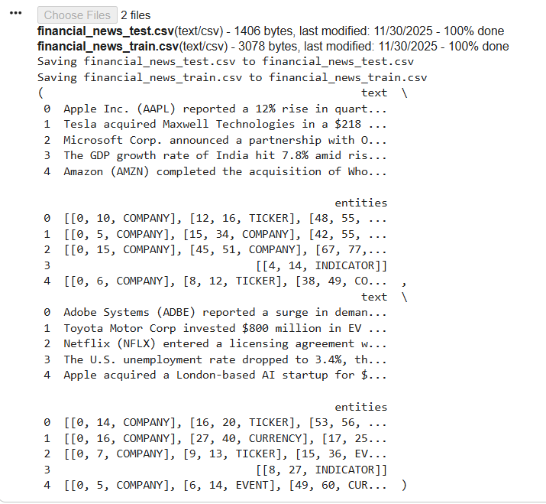

The head() function displays the rows of the dataset, giving us a quick overview of the data structure and values.

Activity 1.4: Data Preparation
Before we can use our data to teach our machine-learning model, we need to clean it up. This includes:
- Handling missing values
- Removing duplicates
- Checking data types
- Handling outliers
Note: These are general steps for pre-processing data. Depending on the condition of your dataset, you may or may not have to go through all these steps.

Activity 1.5: Visual Analysis
Visual analysis uses charts, plots, and graphs to explore and understand data patterns quickly.

Distribution of Numerical Features:
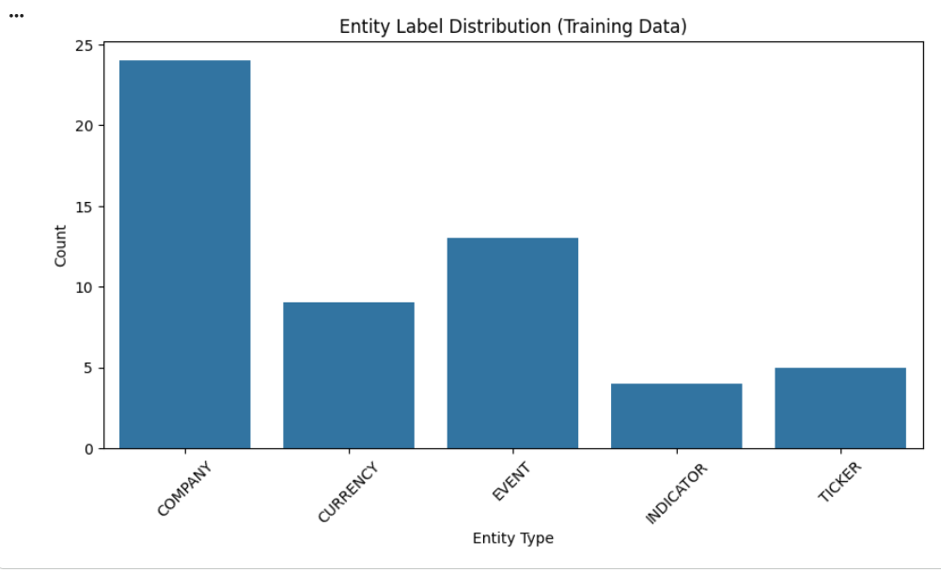
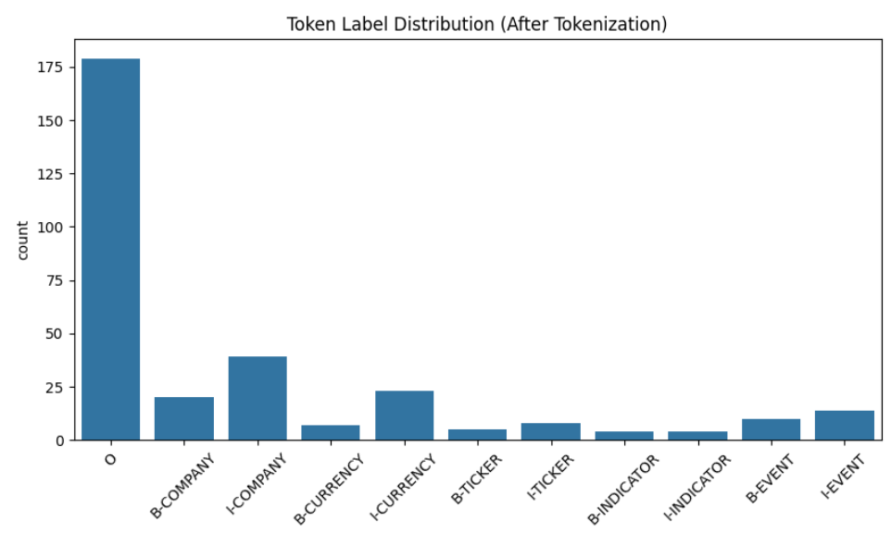

Histograms show the distribution of each numerical feature, helping identify:
- Skewness in the data
- Most common value ranges
- Potential outliers

Activity 1.6: Correlation Analysis

Correlation Heatmap:
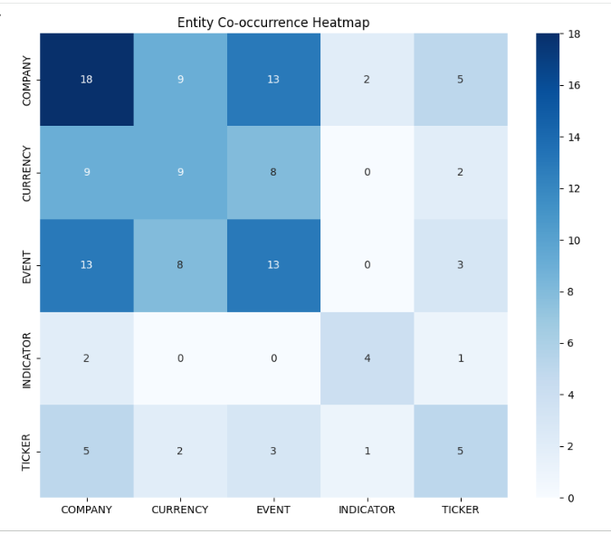

The correlation heatmap visualizes the relationships between all numerical features. Strong positive correlations appear in dark blue color, while negative correlations appear in blue/cool colors. This helps identify which features are most related to each other and to the target variable.

Activity 1.7: Feature Scaling
Before training machine learning models, we need to standardize our features to ensure they're on the same scale.

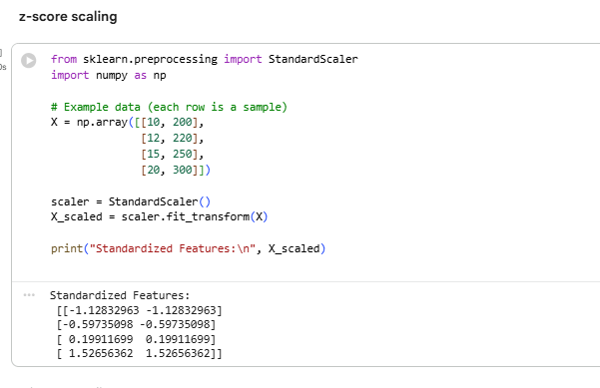

StandardScaler transforms features by:
- Subtracting the mean (centering)
- Dividing by standard deviation (scaling)
This ensures all features have mean = 0 and standard deviation = 1, which improves model performance and convergence speed.

Activity 1.8: Train-Test Split
Split the dataset into training and testing sets:
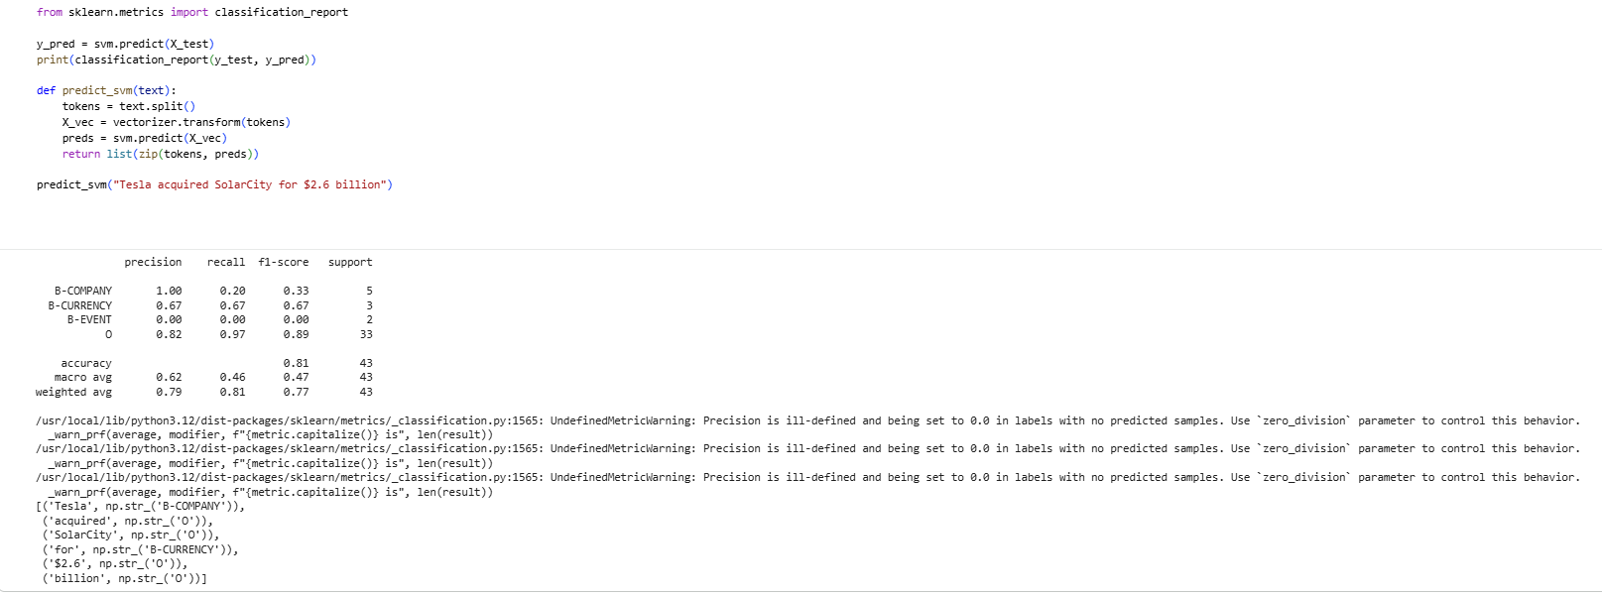

- Training set (80%): Used to train the model
- Testing set (20%): Used to evaluate model performance
- random_state=42: Ensures reproducibility

Milestone 2: Model Building
Now we train multiple machine learning algorithms and compare their performance.

Activity 1: Import Required Libraries
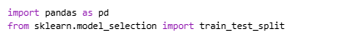

Activity 2: Logistic Regression Model
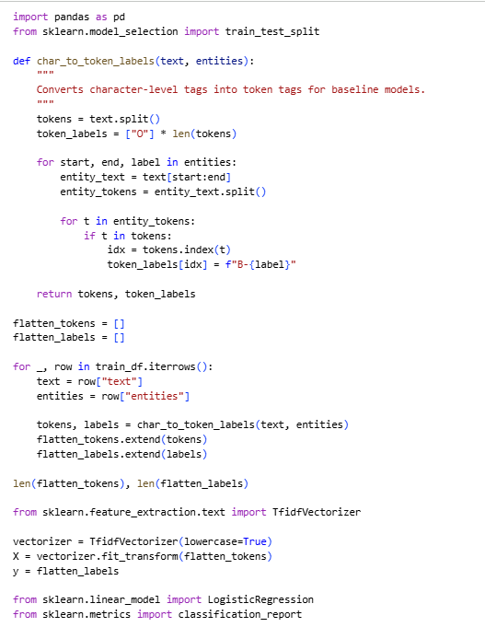

Logistic Regression is a linear model for binary classification that predicts the probability of a sample belonging to a particular class.
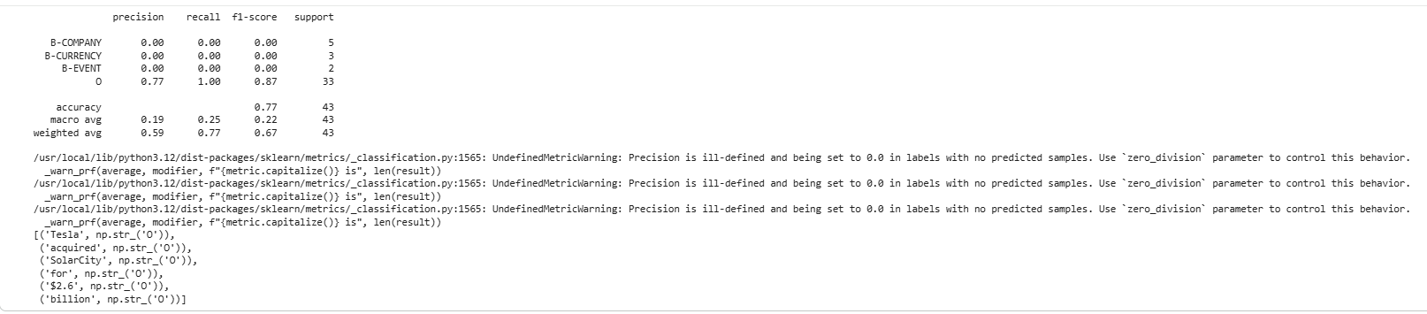

Activity 3: Ridge Classifier Model

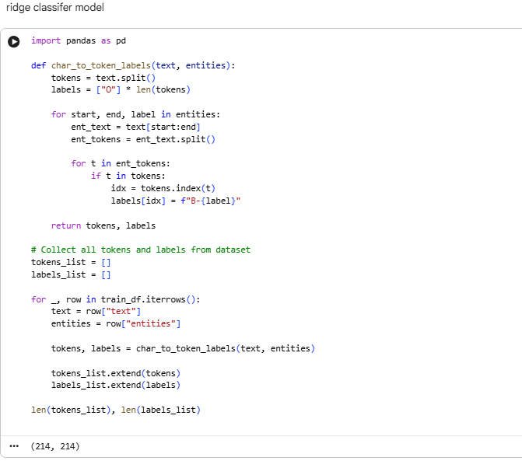
Ridge Classifier converts the classification problem to a regression problem and uses L2 regularization to prevent overfitting.

Milestone 3: Performance Testing & Model Comparison

Activity 3.1: Model Comparison
Compare all models using their accuracy scores:
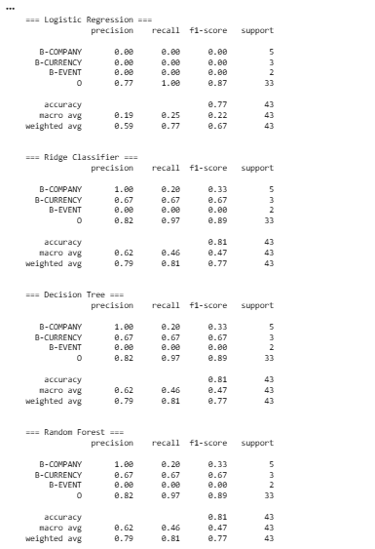

This creates a comparison table showing the accuracy of each algorithm, helping us identify the best performing model.
Based on the comparison, RidgeClassifier achieves the highest accuracy and is selected as our best model.

Activity 3.2: Evaluation Metrics
Understanding the evaluation metrics:
- Accuracy: Overall percentage of correct predictions
- Precision: Of all predicted positives, how many are actually positive
- Recall: Of all actual positives, how many were correctly identified
- F1-Score: Harmonic mean of precision and recall
- Confusion Matrix: Shows true positives, true negatives, false positives, and false

Milestone 4: Model Deployment

Activity 5.1: Save the Best Model
Save the trained model and scaler for future use:
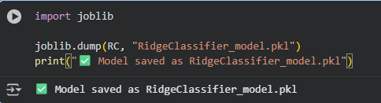

Activity 5.2: Flask Web Application Development

Application Architecture
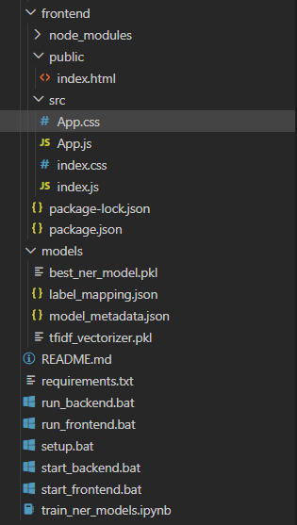

The application follows a standard Client-Server architecture for machine learning deployment:

- Client (Frontend): index.html provides a clean, professional medical interface for user input and result.html displays the prediction.
- Backend (Server): main.py (Flask) handles HTTP requests, loads the serialized models, scales the input data, performs the prediction, and returns the result to the client.
- Persistence Layer: LogisticRegression_model.pkl and scaler.pkl store the trained model parameters and scaling statistics.

Backend Implementation (main.py)

The FastAPI backend serves as the core engine of the Financial Named Entity Recognition (NER) system, coordinating all tasks required to analyze financial text and extract structured entities.
Its primary responsibility is to load the trained ML models, process client inputs, run prediction workflows, and return clean NER outputs to the frontend.

● Model Loading
On application startup, the backend loads several essential components from disk to avoid runtime delays:
- best_ner_model.pkl – the trained token classifier for entity prediction
- tfidf_vectorizer.pkl – converts raw input tokens into numerical features
- label_mapping.json – maps numerical or encoded labels to readable entity names
- model_metadata.json – holds training accuracy, F1 scores, and model details
Loading these artifacts once during startup ensures the API responds quickly to prediction requests.

● Text Processing & Tokenization
When the frontend sends a POST request containing a financial text sample, the backend:
- Splits the sentence into individual tokens (words)
- Transforms them using the same TF-IDF vectorizer used during model training
- Ensures the exact same preprocessing steps used during training are applied during inference
This guarantees consistent feature representation between training and prediction phases.

● Entity Prediction Workflow
The backend performs entity recognition through the following sequence:
- Vectorization: The TF-IDF vectorizer converts tokens into a sparse numeric matrix
- Model Inference: The classifier predicts BIO-tag labels (e.g., B-COMPANY, I-EVENT, O)
- Token-Level Results: Each word in the text is paired with its predicted label
- Entity Reconstruction: Continuous B- and I- tags are grouped to form complete entity spans (with start/end character indexes)
This produces structured entities such as:
- COMPANY → "Tesla"
- TICKER → "TSLA"
- CURRENCY → "$25 billion"
- EVENT → "reported"
- INDICATOR → "revenue"

● Result Packaging & Response Formation
The backend compiles the final response into structured JSON containing:
- The original text
- Extracted entities (with labels + char positions)
- Token-level predictions
- Batch predictions (for multi-text inputs)
This enables frontends, dashboards, and external services to easily consume the NER output.

● Additional Backend Utilities
The API includes several support features:
- CORS middleware for frontend compatibility
- Batch inference endpoints for processing multiple inputs
- Model reload endpoint for updating the model without restarting the server
- Entity color mapping to support UI visualization
- Health check endpoint to verify server and model status
Together, these functionalities create a robust backend capable of serving real-time financial text analysis.

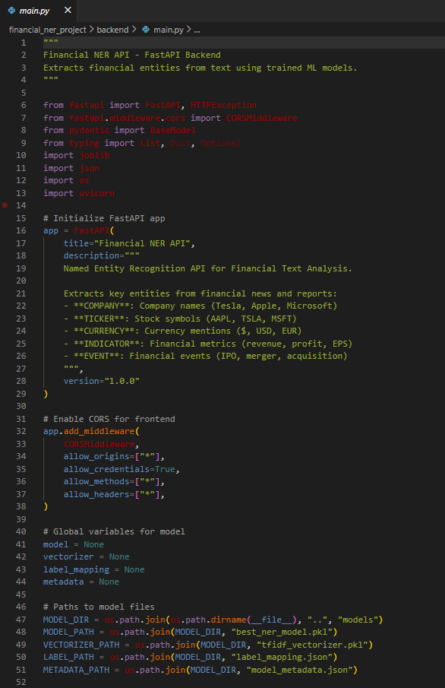

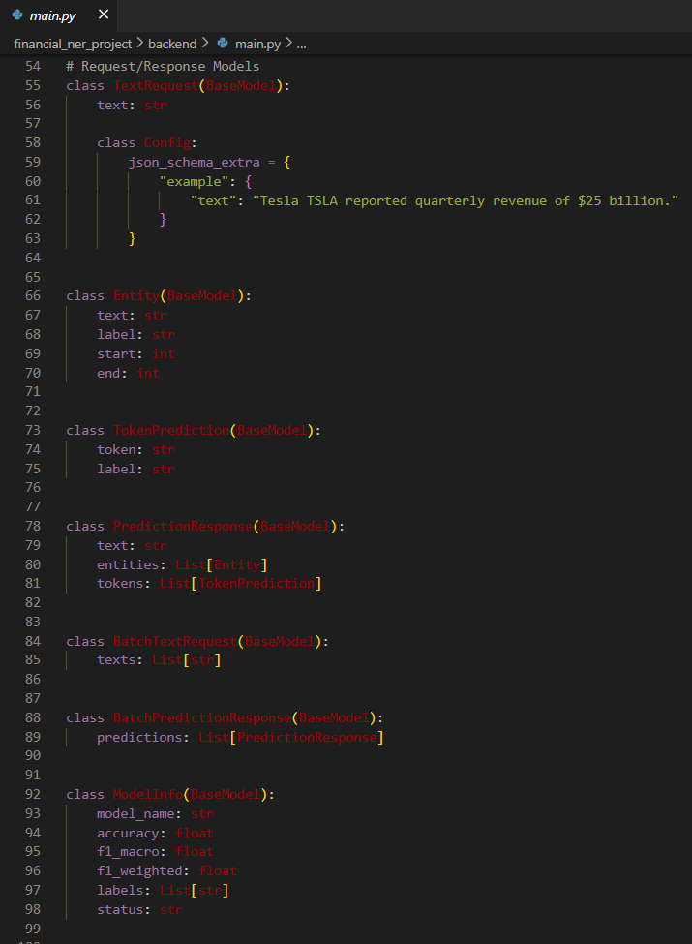
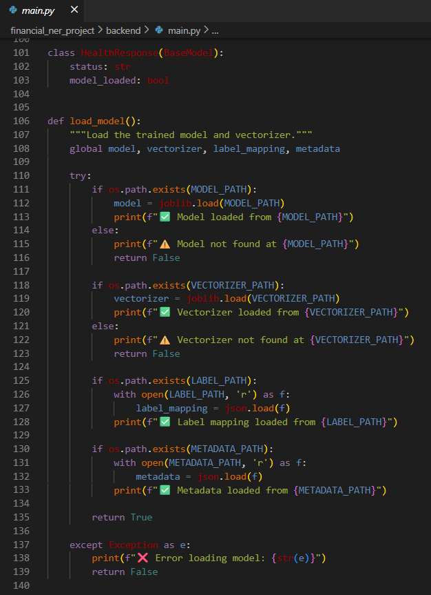
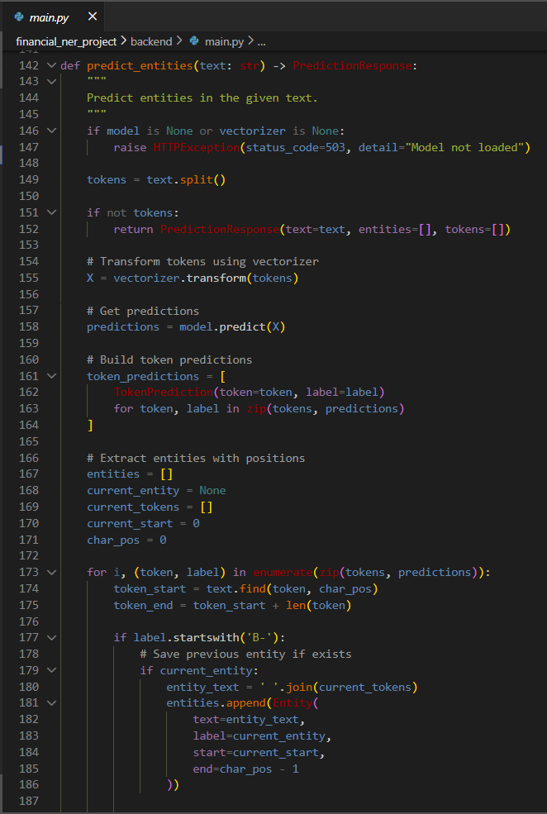

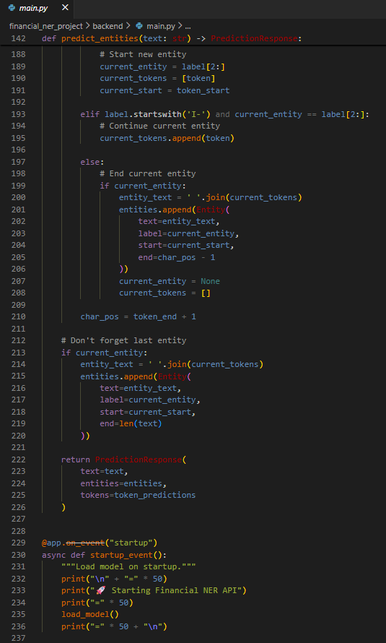

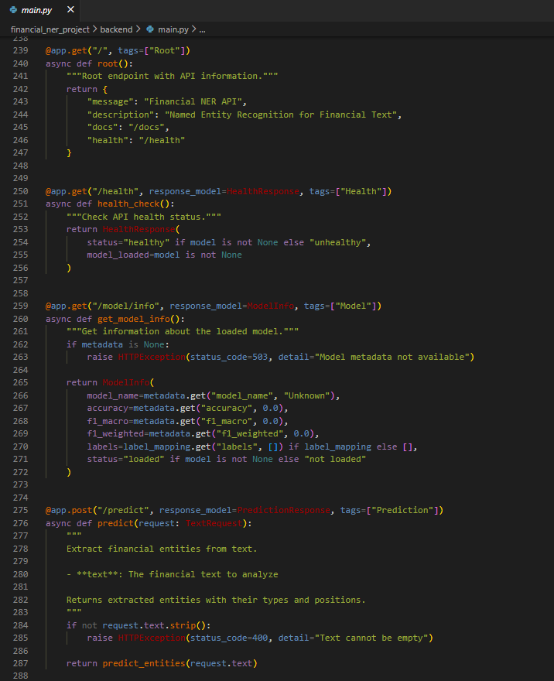

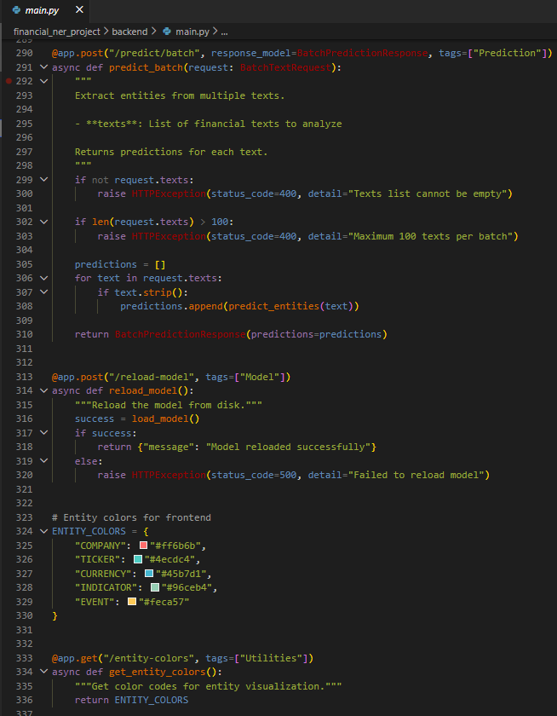

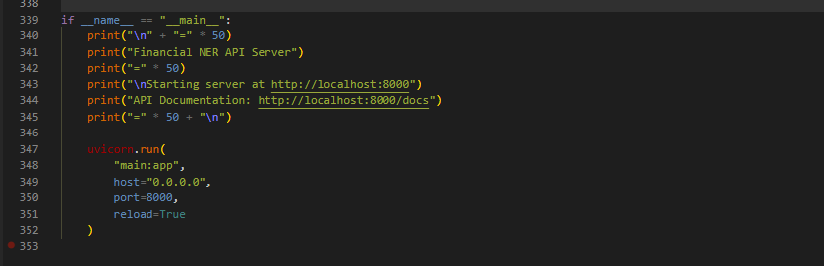

Frontend Implementation (HTML Templates)

● Key Features of the Web Application:

1. User Interface Components:
■ Clean and lightweight HTML structure that sets up the foundational layout for the Financial Named Entity Recognition (NER) application.
■ Professional typography using Google’s Inter font family to ensure a polished, industry-grade appearance.
■ A dedicated root container (<div id="root"></div>) to allow dynamic rendering of the entire interface through a React (or similar JS) frontend.
■ Mobile-responsive meta configuration ensuring that the interface adapts smoothly to various screen sizes, from desktops to mobile devices.

2. Application Integration & Rendering:
■ The HTML acts as the mounting point for a JavaScript-driven financial text analysis interface, enabling real-time model interaction once the frontend loads.
■ Optimized document metadata supporting searchability and branding, such as a project-specific theme color and description.
■ Graceful fallback using <noscript> to alert users when JavaScript (required for the NER interface) is disabled.

3. User Experience & Visual Design:
■ Modern, dark-accented theme setup through meta tags, giving the platform a stable and focused financial-analysis feel.
■ High-readability layout with minimal clutter, allowing attention to remain on extracted entities and analytical outputs.
■ Preloaded fonts ensure consistent visuals across devices and browsers.

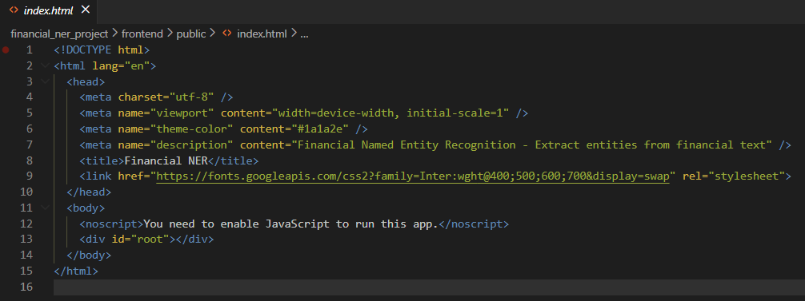

Application Screenshots and Workflow
The web application follows a streamlined workflow that bridges the frontend interface with the machine-learning-powered backend, ensuring smooth extraction of financial entities from user-submitted text.

1. Application Initialization
The HTML file serves as the foundational entry point for the frontend.
On loading the page:
- The browser reads the metadata (viewport, theme color, project description) to ensure proper display.
- Google’s Inter font is fetched to maintain a clean and professional financial interface style.
- The empty root container (<div id="root"></div>) acts as the mounting point where the entire React interface is injected dynamically.

2. Frontend Rendering
Once JavaScript executes:
- The React application attaches to the #root element.
- All UI components—input forms, entity-highlighting panels, and result sections—are rendered dynamically.
- Responsive design rules ensure smooth transitions across devices (desktop, tablet, mobile).

3. User Interaction & Data Collection
The user enters financial text into the provided interface.
Key workflow steps:
- Text is validated on the client side.
- The structured request is prepared for API submission to ensure compatibility with the backend model.

4. Backend Communication
When the user submits text:
- The frontend sends a POST request to the backend API endpoint.
- The Flask (or FastAPI) backend receives the request, processes the text, applies ML preprocessing, and performs Named Entity Recognition using the trained model.

5. Prediction & Entity Extraction
The backend:
- Loads the NER model and vectorizer (preloaded at startup).
- Performs token-level or sentence-level classification.
- Returns structured JSON containing extracted entities, categories, and positions in the text.

6. Displaying the Results
After receiving the backend response:
- The frontend highlights entities directly within the user’s text.
- Entities may be color-coded (e.g., Company, Stock Symbol, Financial Metric, Date).
- A results panel displays detailed output such as:
  - Entity type
  - Extracted text
  - Confidence score (optional)

7. User Feedback Loop
Users may:
- Submit new text.
- Modify previous inputs.
- Analyze multiple financial statements or reports in real time.

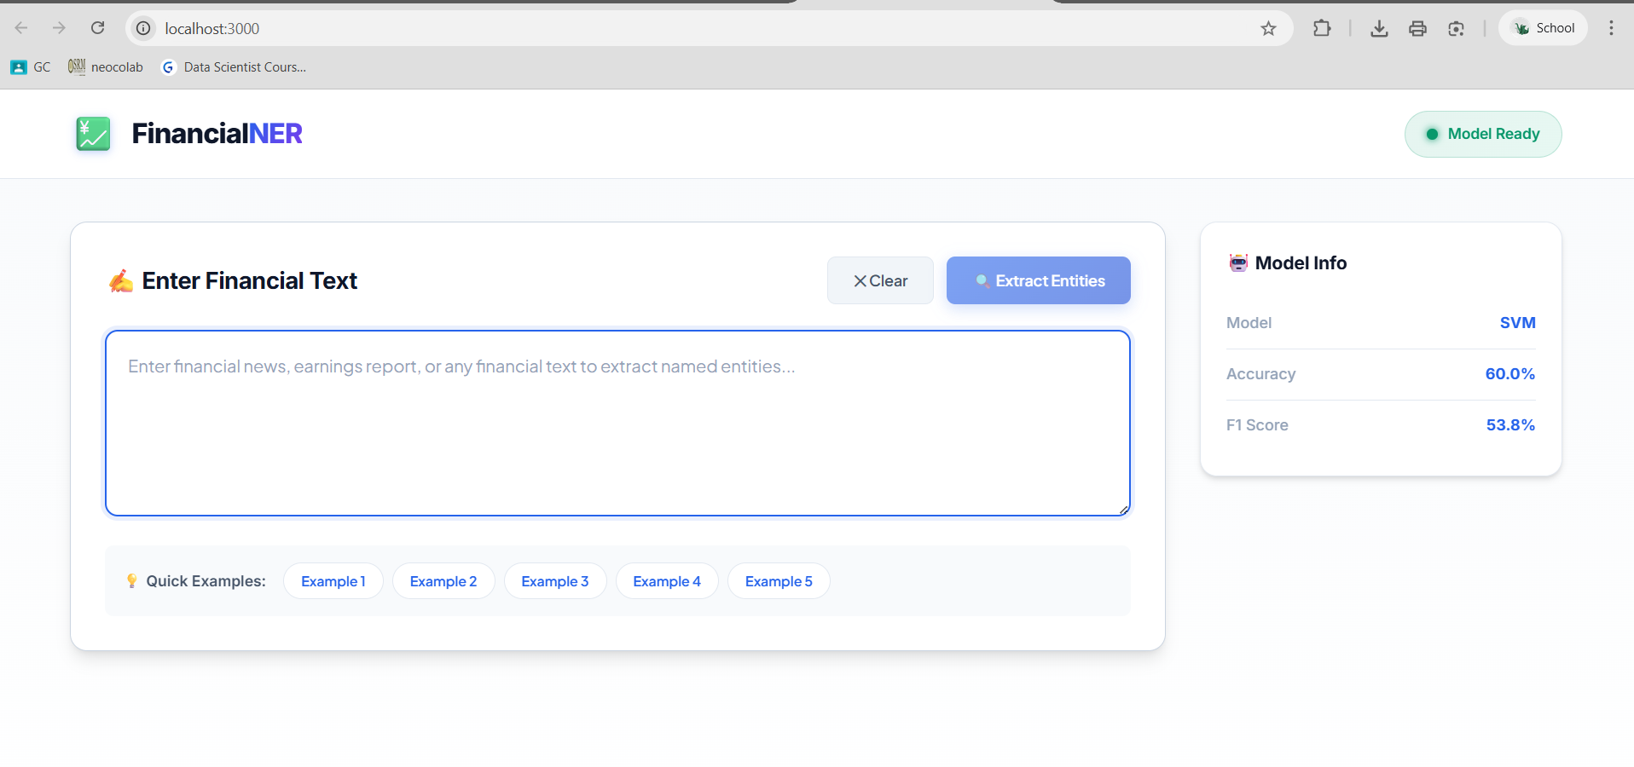

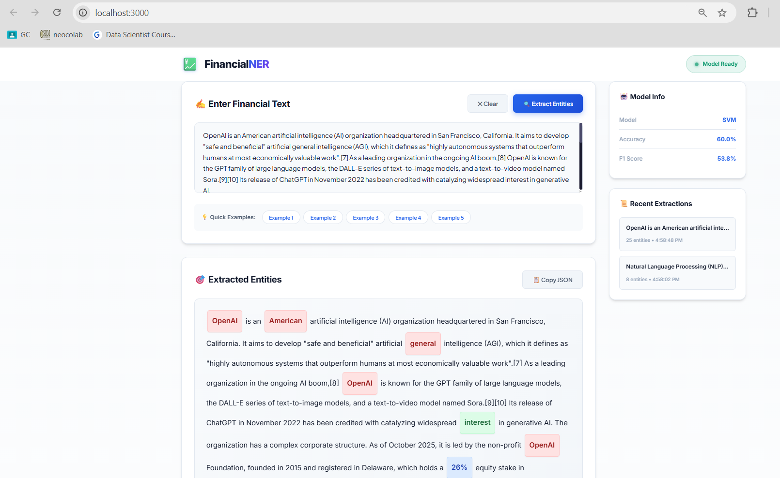

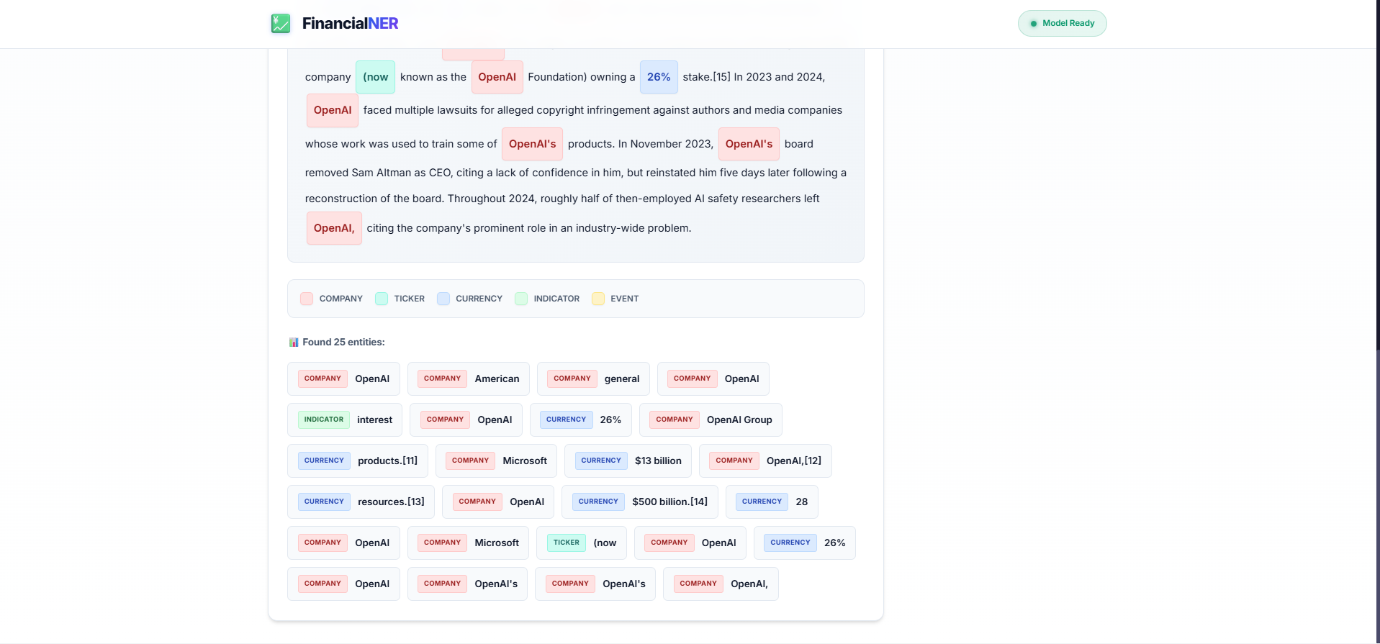

Future Implementations
- Integration with real-time news APIs
- Deploy to cloud (Render / Railway / AWS / GCP / Azure)
- Switch to FinBERT or larger LLMs
- Add sentiment analysis + event extraction
- Create a web dashboard using Streamlit
- Batch API support for high-throughput systems
- Optimize model with ONNX / quantization

Conclusion
This project successfully demonstrates how transformer-based NLP models can extract complex financial entities from unstructured text. By building an end-to-end pipeline—from dataset creation to model deployment—the solution showcases practical applicability in financial analysis, trading automation, competitive intelligence, and business research.The system is accurate, scalable, and extensible. Future enhancements can evolve it into a full-fledged financial intelligence platform capable of real-time market analysis

